This is the link to my review:

[https://review.udacity.com/?utm_medium=email&utm_campaign=ret_000_auto_ndxxx_submission-reviewed&utm_source=blueshift&utm_content=reviewsapp-submission-reviewed&bsft_clkid=71c91eed-dc6d-4252-a9e5-ffd0257fc217&bsft_uid=cd0c7a84-50c4-4469-b996-454831085470&bsft_mid=68b55cc2-dcc9-4457-b17d-fa54ab1cf9ec&bsft_eid=6f154690-7543-4582-9be7-e397af208dbd&bsft_txnid=05be269d-3f3f-4db3-9a63-2674cc0e2f2c#!/reviews/1049766](https://urldefense.proofpoint.com/v2/url?u=https-3A__review.udacity.com_-3Futm-5Fmedium-3Demail-26utm-5Fcampaign-3Dret-5F000-5Fauto-5Fndxxx-5Fsubmission-2Dreviewed-26utm-5Fsource-3Dblueshift-26utm-5Fcontent-3Dreviewsapp-2Dsubmission-2Dreviewed-26bsft-5Fclkid-3D71c91eed-2Ddc6d-2D4252-2Da9e5-2Dffd0257fc217-26bsft-5Fuid-3Dcd0c7a84-2D50c4-2D4469-2Db996-2D454831085470-26bsft-5Fmid-3D68b55cc2-2Ddcc9-2D4457-2Db17d-2Dfa54ab1cf9ec-26bsft-5Feid-3D6f154690-2D7543-2D4582-2D9be7-2De397af208dbd-26bsft-5Ftxnid-3D05be269d-2D3f3f-2D4db3-2D9a63-2D2674cc0e2f2c-23-21_reviews_1049766&d=DwMFaQ&c=DDPRwrN9uYSNUDpKqPeD1g&r=rIGnDhQ9_H93TGuIED-sYxlVox5lg7tCbwLQzFv0G4k&m=Rbydew05B0ukh_70QxXaptMcl3KiY7Mbh5_ZQU168EE&s=Ngfugcqn4Zem5_k1ovx85lswmVZvWtOMM0XUYZUsQFY&e=)

I am unclear on what I should revise using this feedback. Please advise.

**Feedback:**

After reading the file, the user should have the opportunity to choose if to analyze the month or day etc. Please make sure the users have the option to choose the analysis that is performed as specify in the instructions.

Please see the snippet of my code results below. My code asks for user input to filter by month & month name or day & day name or none. Based on these choices the results are computed. What is the expectation based on this feedback?

**Code Sample 1:**

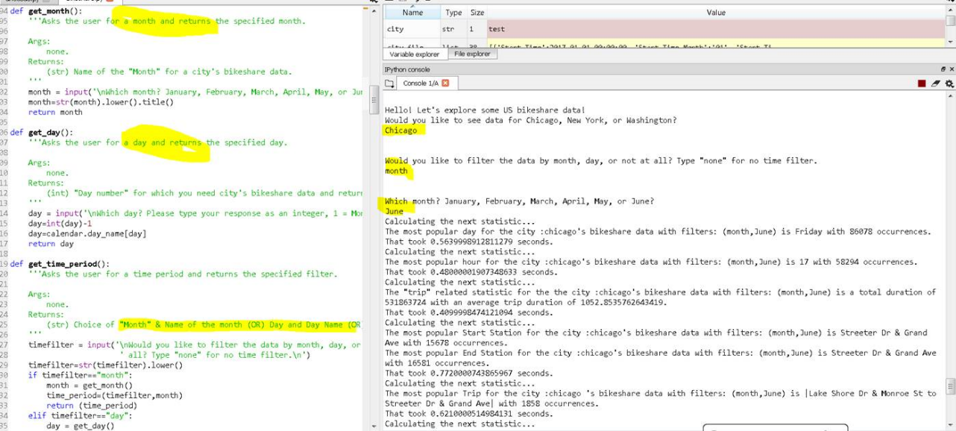

**Code Sample 2:**

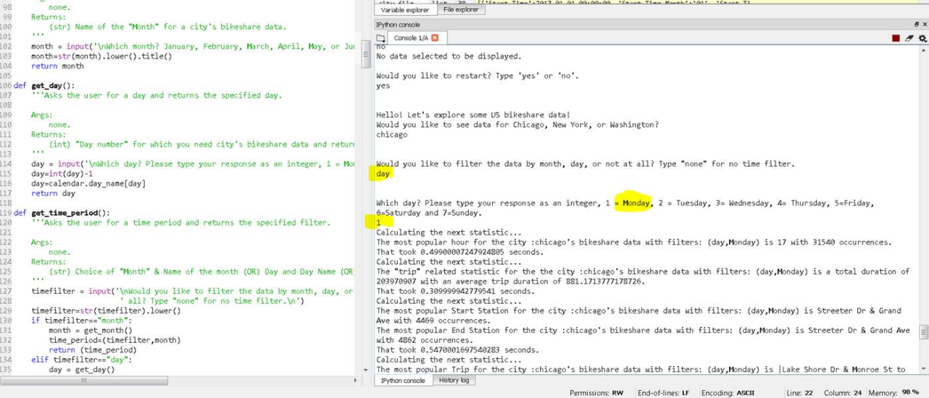

**Code Sample 3:**

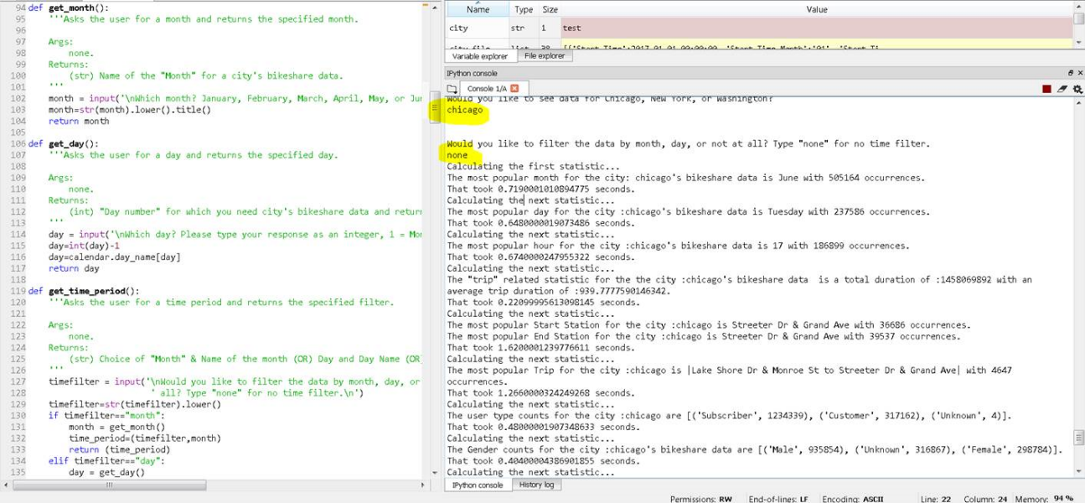

Thanks,

Archana Krishnamurthy